**Chapter # 06 (Trigonometric Function)**

**6.4 Graphs of the Sine and Cosine Functions:**

**Objectives:** 1 Graph Functions of the Form $y=A sin{(ωx)}$ Using Transformations

2 Graph Functions of the Form $y=A cos{(ωx)}$ Using Transformations

3 Determine the Amplitude and Period of Sinusoidal Functions

4 Graph Sinusoidal Functions Using Key Points

5 Find an Equation for a Sinusoidal Graph

**The Graph of the sine function, $y=\sin{x}$:** Because the sine function has period $2π$, it is only necessary to graph $y=\sin{x}$ on the interval $\left[0, 2π\right]$. The remainder of the graph will consist of repetitions of this portion of the graph.

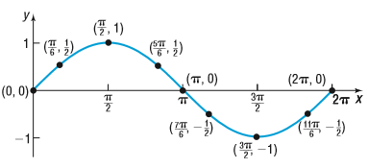

**Figure: $y=\sin{x, 0≤x≤2π}$**

The graph in above figure is one period, or cycle, of the graph of $y=\sin{x}$. To obtain a more complete graph of $y=\sin{x}$, continue the graph in each direction, as shown in the following figure:

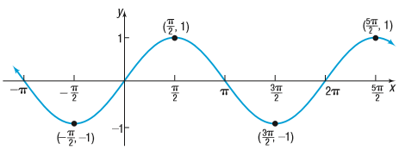

**Figure: $y=\sin{x, -∞<x<∞}$**

**Properties of the sine function, :**

1. The domain is the set of all real numbers.

2. The range consists of all real numbers from -1 to 1, inclusive.

3. The sine function is an odd function, as the symmetry of the graph with respect to

the origin indicates.

4. The sine function is periodic, with period .

5. The *x*-intercepts are $…,…, -2π, -π, 0, π, 2π, … …,$; the *y*-intercept is 0.

6. The maximum is 1 and occurs at $x= …, -\frac{3π}{2}, \frac{π}{2}, \frac{5π}{2}, …$

the minimum value is -1 and occurs at $x= …, -\frac{π}{2}, \frac{3π}{2}, \frac{7π}{2}, …$

**Example 1:** Draw the graph of $y=3\sin{x}$ using transformations. Use the graph to determine the domain and the range of the function.

**Solution:**

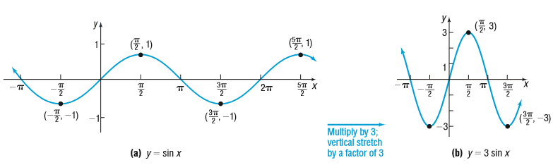

The domain of $y=3\sin{x}$ is the set of all real numbers, $\left(-∞, ∞\right)$. The range is $\left\{y: -3≤y≤3\right\}$, or $[-3, 3]$

**The Graph of the cosine function, $y=\cos{x}$:**

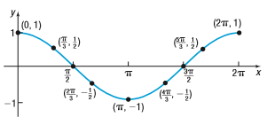

**Figure: $y=\cos{x, 0≤x≤2π}$**

A more complete graph of $y=\cos{x}$ is obtained by continuing the graph in each direction, as shown in following figure.

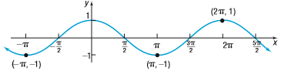

**Figure: $y=\cos{x, -∞<x<∞}$**

**Properties of the cosine function:**

1. The domain is the set of all real numbers.

2. The range consists of all real numbers from -1 to 1, inclusive.

3. The cosine function is an even function, as the symmetry of the graph with respect to

the *y*-axis indicates.

4. The cosine function is periodic, with period .

5. The x-intercepts are $…,…, -\frac{3π}{2}, -\frac{π}{2}, \frac{π}{2}, \frac{3π}{2}, … …,$; the *y*-intercept is 1.

6. The maximum value is 1 and occurs at $x= …, -2π, 0, 2π, 4π, …;$

the minimum value is -1 and occurs at $x= …, -π, π, 3π, 5π …$.

**Example 3:** Draw the graph of $y=2\cos{3x}$ using transformations. Use the graph to determine the domain and the range of the function.

**Solution:**

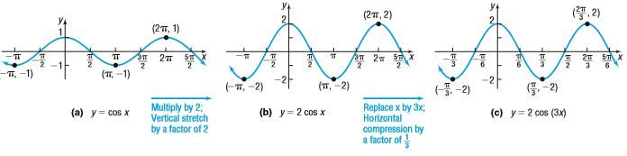

The domain of $y=2\cos{3x}$ is the set of all real numbers, $\left(-∞, ∞\right)$. The range is $\left\{y: -2≤y≤2\right\}$, or $[-2, 2]$. Notice in **figure (c)** that the period of the function $y=2\cos{3x}$ is $\frac{2π}{3}$.

**Sinusoidal Graphs:** Shift the graph of $y=\cos{x}$ to the right $\frac{π}{2}$ units to obtain the graph of $y=\cos\left(x-\frac{π}{2}\right)$, figure (a) . Now look at the graph of in figure (b). Notice th $y=\sin{x}$ at the graph of $y=\sin{x}$ is the same as the graph of $y=\cos\left(x-\frac{π}{2}\right)$.

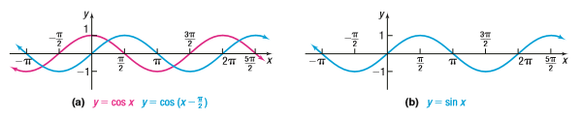

Based on the above figure, we conjecture that

$\sin{x=\cos\left(x-\frac{π}{2}\right)}$

**Theorem:** If $ω>0$, the amplitude and period of $y=A\sin{(ωx)}$ and $y=A\cos{(ωx)}$ are given by: Amplitude = $\left|A\right|$ and Period = *T* = $\frac{2π}{ω}$

**Example 4:** Determine the amplitude and period of $y=3\sin{(4x)}$.

**Solution:** Comparing $y=3\sin{(4x)}$ to $y=A\sin{(ωx)}$, note that *A* = 3 and $ω=4$.

$∴$ Amplitude= $\left|A\right|=3$, Period = $T=\frac{2π}{ω}= \frac{2π}{4}=\frac{π}{2}$

**Steps for Graphing a Sinusoidal Function of the Form $y=A\sin{(ωx)}$ or $y=A\cos{(ωx)}$ Using Key Points:**

**Step1:** Determine the amplitude and period of the sinusoidal function.

**Step2:** Divide the interval $\left[0, \frac{2π}{ω}\right]$ into four subintervals of the same length.

**Step3:** Use the endpoints of these subintervals to obtain five key points on the graph.

**Step4:** Plot the five key points, and draw a sinusoidal graph to obtain the graph of one

cycle. Extend the graph in each direction to make it complete.

**Example 6:** Draw the graph of $y=2\sin\left(-\frac{π}{2}x\right)$

**Solution:** Since the sine function is odd, use the equivalent form: $y=-2\sin\left(\frac{π}{2}x\right)$

**Step1:** Here, $A=-2 and ω=\frac{π}{2}$

$∴$ The amplitude is = $\left|A\right|=\left|-2\right|=2$ and the period is= $\frac{2π}{ω}=\frac{2π}{\frac{π}{2}}=4$

The graph $y=-2\sin\left(\frac{π}{2}x\right)$ lies between -2 and 2 on the *y*-axis. One cycle will begin at *x* = 0 and end at *x* = 4.

**Step2:** Divide the interval $[0, 4]$ into four subintervals, each of length $4÷4=1$. The *x*-coordinates of the five key points are: 0, 1, 2, 3, 4

**Step3:** The five key points on the graph are: $\left(0, 0\right) \left(1, -2\right) \left(2, 0\right) \left(3, 2\right), (4, 0)$

**Step4:** Plot these five points, and fill in the graph of the sine function as shown in figure

(a) and extend the graph in each direction to obtain figure (b).

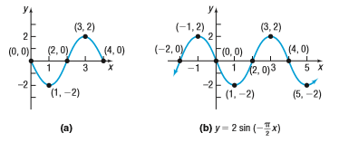

**Example 8:** Find an equation for the following graph:

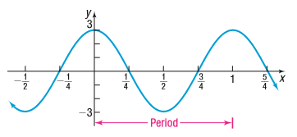

**Solution:** The maximum value, 3, occurs at x = 0. So the equation can be viewed as a cosine function $y=A\cos{(ωx)}$ with *A* = 3 and period *T* = 1. Then $\frac{2π}{ω}=1 ⇒ω=2π$.

$∴$ The cosine function whose graph is given in the question is

$y=A\cos{(ωx)}=3cos⁡(2πx)$ Ans.

**Home Work: Exercise 6.4: Problem No. 11 - 48 and 57- 70**

**Exercise 6.4:**

**Question no. 11- 22 are same:**

**Question 14:** Determine the amplitude and period of the following function without graphing: $y=2\sin{x}$

**Solution:** Given, $y=2\sin{x}$

Here, $A=2, ω=1$ $∴$ Amplitude= $\left|A\right|=2$, Period = $T=\frac{2π}{ω}= \frac{2π}{1}=2π$ Ans.

**Question 20:** Determine the amplitude and period of the following function without graphing: $y=-\frac{1}{2}\cos\left(\frac{3}{2}x\right)$

**Solution:** Given, $y=-\frac{1}{2}\cos\left(\frac{3}{2}x\right)$

Here, $A=-\frac{1}{2}, ω=\frac{3}{2}$ $∴$ Amplitude= $\left|A\right|=\left|-\frac{1}{2}\right|=\frac{1}{2}$, Period = $T=\frac{2π}{ω}= \frac{2π}{\frac{3}{2}}=\frac{4π}{3}$ Ans.

**Question no. 23- 32 are same: (Matching)**

**Question no. 33- 48 are same:**

**Question 37:** Draw the graph of the following function using transformations or the method of key points. Use the graph to determine the domain and the range: $y=\sin{(3x)}$

**Solution:** Given, $y=\sin{(3x)}$

Here, Amplitude = $\left|A\right|=\left|1\right|=1$ and Period = $\frac{2π}{ω}= \frac{2π}{3}$

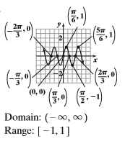

**Question 41:** Draw the graph of the following function using transformations or the method of key points. Use the graph to determine the domain and the range:

**Solution:** Given, , Here,

